**WEEK 6**

create database Employee;

use Employee;

create table dept

(

deptno int,

dname varchar(20),

dloc varchar(20),

primary key(deptno)

);

create table employee

(

empno int,

ename varchar(20),

mgr_no int,

hiredate date,

sal double,

deptno int,

primary key(empno),

foreign key (deptno) references dept(deptno) on delete cascade on update cascade

);

create table incentives

(

empno int ,

incentive_date date,

incentive_amount double,

primary key(empno,incentive_date),

foreign key(empno) references employee(empno) on update cascade on delete cascade

);

create table project

(

pno int,

pname varchar(20),

ploc varchar(20),

primary key(pno)

);

create table assigned_to

(

empno int,

pno int,

job_role varchar(20),

primary key(empno,pno),

foreign key(empno) references employee(empno) on update cascade on delete cascade,

foreign key(pno) references project(pno) on update cascade on delete cascade

);

insert into dept values

(1,'CSE','bangalore'),

(2,'ISE','bangalore'),

(3,'AIML','hyderabad'),

(4,'ECE','mysuru'),

(5,'EEE','delhi'),

(6,'IEM','chennai');

insert into employee values(10,'Shreesha',21,'2000-03-03',100000,1),

(20,'Nishanth',10,'2003-02-02',90000,2),

(30,'Pratheek',10,'2006-03-03',80000,3),

(40,'Saikiran',20,'2007-07-06',70000,4),

(50,'Aditi',30,'2009-07-09',60000,5),

(60,'Nidheesh',40,'2013-08-03',50000,6),

(70,'Dhanya',40,'2009-08-22',50000,1),

(80,'Pavan',50,'2015-08-22',50000,2),

(90,'Preethi',50,'2020-04-22',60000,3),

(100,'Varshitha',60,'2021-10-22',55000,4);

insert into incentives values(10,'2002-09-02',30000),

(20,'2005-06-04',20000),

(30,'2008-02-25',10000),

(40,'2014-06-02',5000),

(50,'2017-09-06',3000),

(70,'2021-12-06',6000),

(80,'2021-12-06',4000),

(90,'2021-12-06',2000);

insert into project values(100,'p1','bangalore'),

(200,'p2','bangalore'),

(300,'p3','mysuru'),

(400,'p4','hyderabad'),

(500,'p5','delhi'),

(600,'p6','mumbai'),

(700,'p7','kolkata');

insert into assigned_to values(10,100,'manager'),

(20,200,'teamlead'),

(30,300,'analyst'),

(40,400,'programmer'),

(50,500,'teamlead'),

(60,600,'manager'),

(70,700,'teamlead');

**To Do:**

**3.**

select e1.ename

from employee e1, employee e2

where e1.empno=e2.mgr_no group by e1.ename

having count(e1.mgr_no)=(select count(e1.ename)

from employee e1, employee e2 where e1.empno=e2.mgr_no

group by e1.ename order by count(e1.ename) desc limit 1);

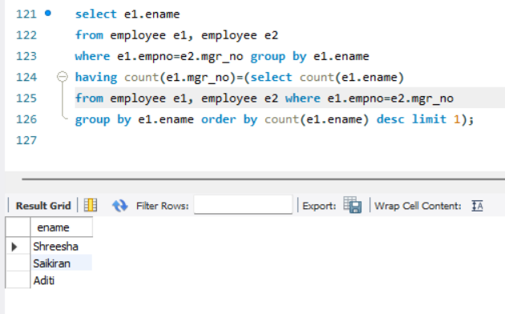

**4.**

select m.ename from employee m

where m.empno in

(select mgr_no from employee)

and m.sal>(select avg(n.sal) from employee n

where n.mgr_no=m.empno);

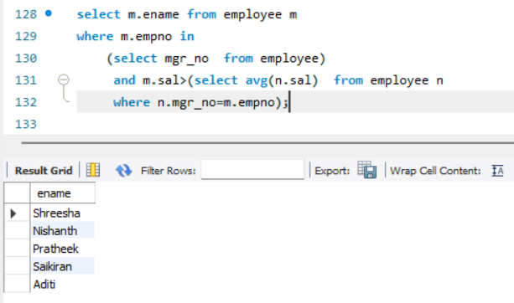

**5.**

select ename from employee where empno in(select distinct mgr_no

from employee where empno in

(select distinct mgr_no from employee where empno in

(select distinct mgr_no from employee)));

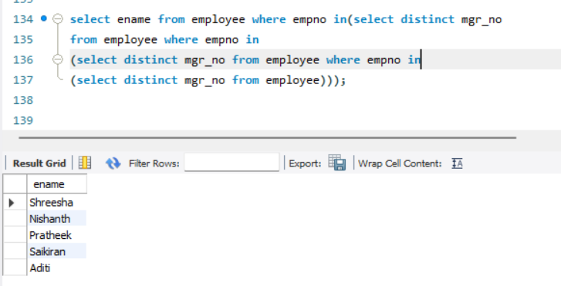

**6.**

select * from employee where empno=

(select i.empno from incentives i

where i.incentive_amount= (select max(n.incentive_amount) from incentives n

where n.incentive_amount<(select max(inc.incentive_amount) from incentives inc

where inc.incentive_date between '2019-01-01' and '2019-12-31') and incentive_date between '2019-01-01' and '2019-12-31'));

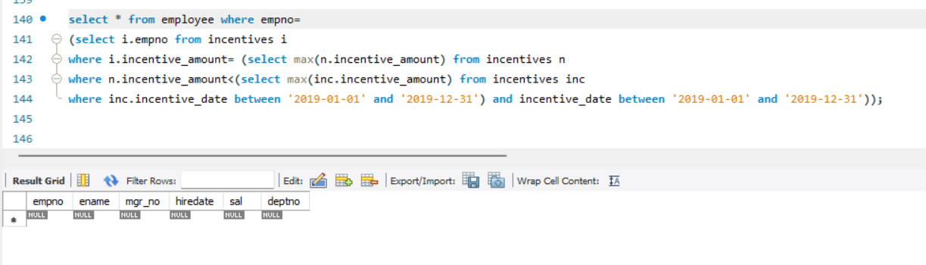

**7.**

select e2.ename

from employee e1, employee e2

where e1.empno=e2.mgr_no and e1.deptno=e2.deptno;

